-These

* 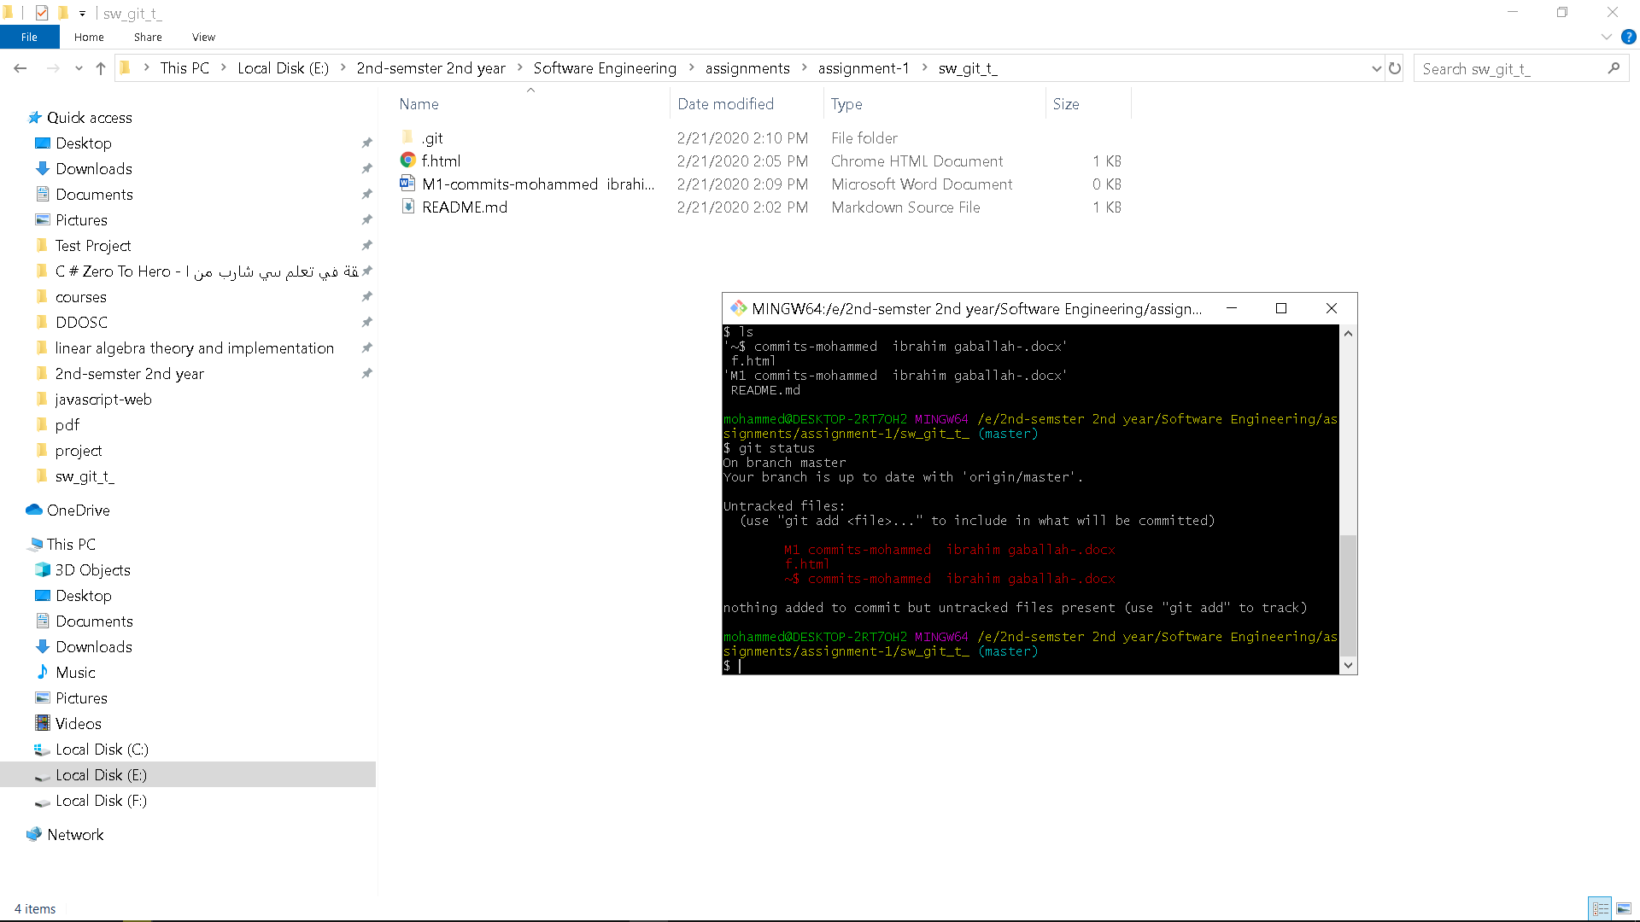after making f.html and running git status

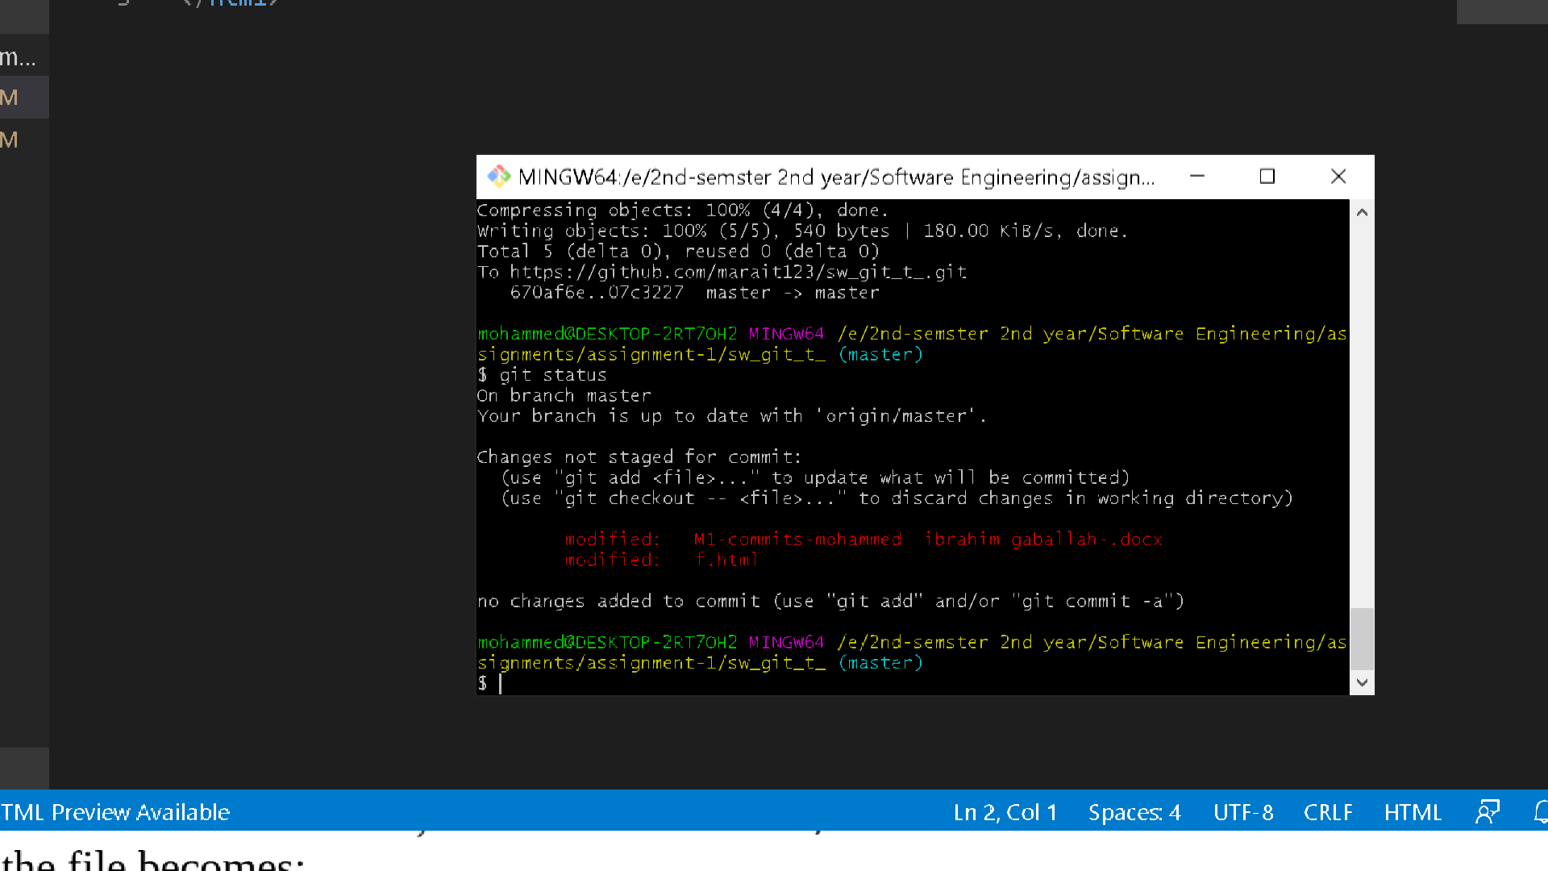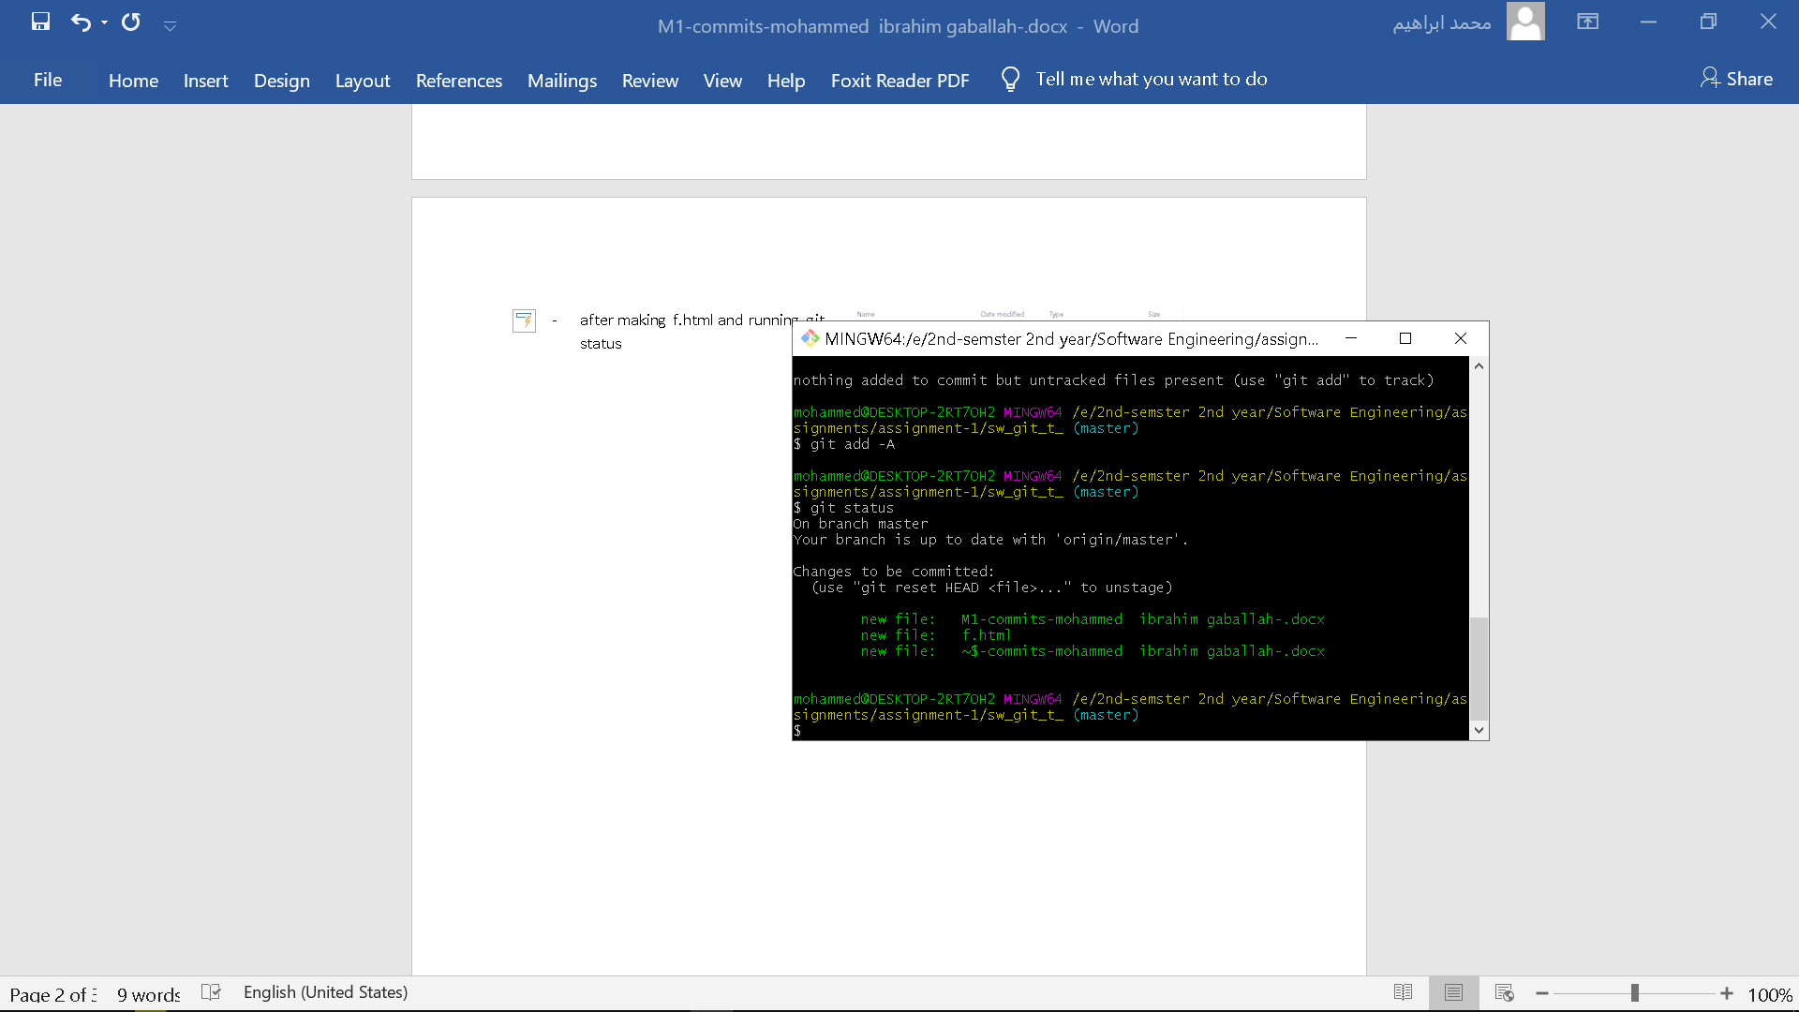

Step 7 after modifying the middle element.

Running git status before running git commit and after running ‘git add -A’